**PRACTICAL 8 : Temperature Data Logging to ThingSpeak Cloud**

**Aim :** To send temperature sensor data to the ThingSpeak cloud using Arduino and NodeMCU.

**Overview :**

In this project, a temperature sensor is used to collect data, which is then sent to the ThingSpeak cloud platform using Arduino and NodeMCU. This experiment introduces cloud-based data storage, remote monitoring and IoT communication protocols.

**Materials Required :**

* Arduino Uno R3
* 2 x 1 kΩ Resistor
* Temperature Sensor (TMP36)
* Wifi Module (ESP8266)
* Jumper Wires
* Arduino IDE (Installed on your Computer)

**Circuit Connection and Steps :**

1. **Power Connections :** 
   * TMP36 VCC → 5V (Arduino), GND → GND (Arduino)
   * ESP8266 VCC & CH_PD → 3.3V (Arduino), GND → GND (Arduino)
2. **Sensor & ESP8266 Wiring :**
   * TMP36 VOUT → A0 (Arduino)
   * ESP8266 TX → RX (Arduino) via 1kΩ resistor
   * ESP8266 RX → TX (Arduino) via voltage divider (two 1kΩ resistors)

**Circuit Diagram :**

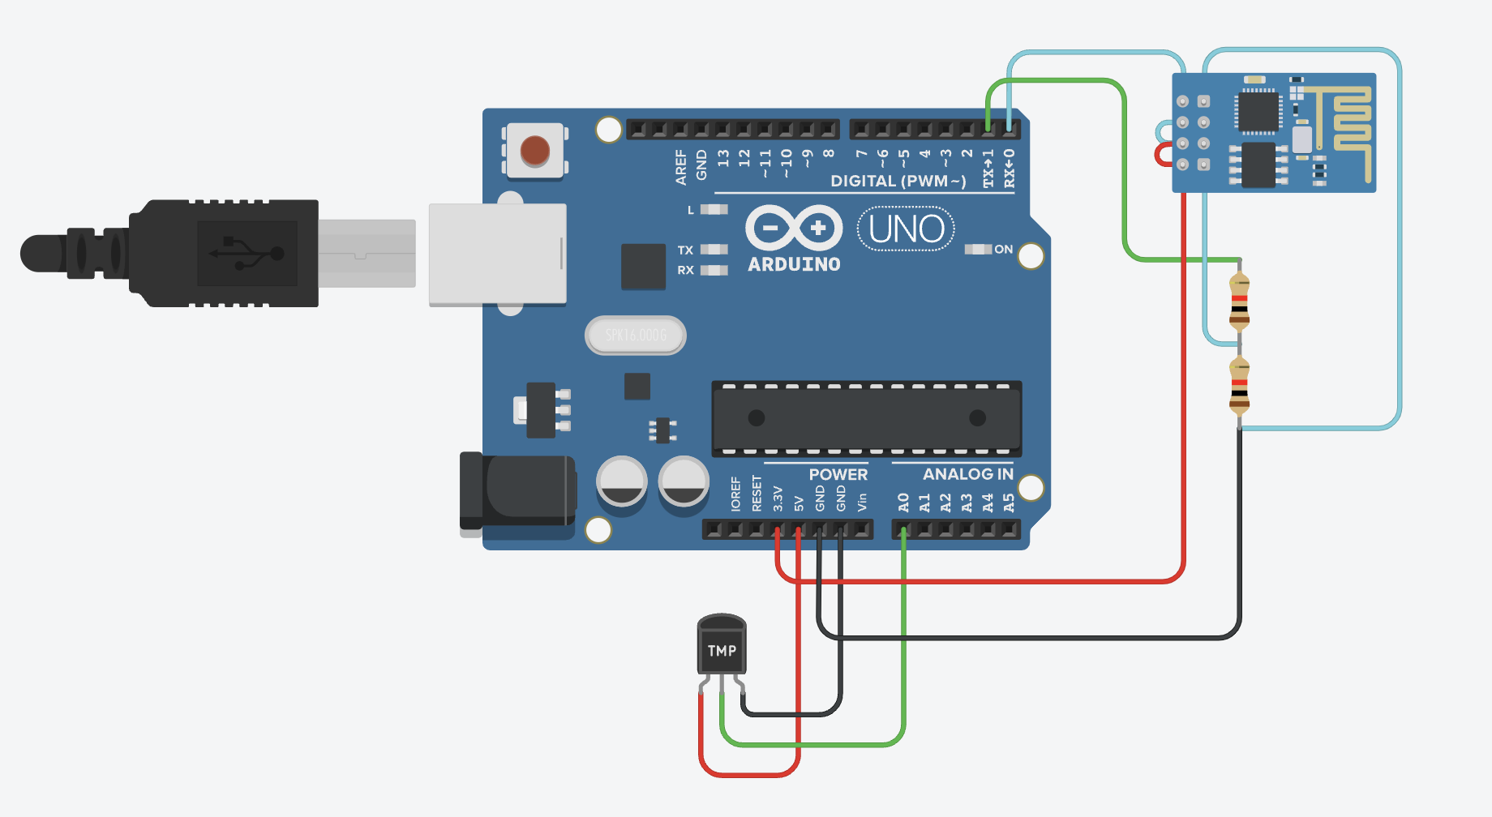

**Schematic Diagram :**

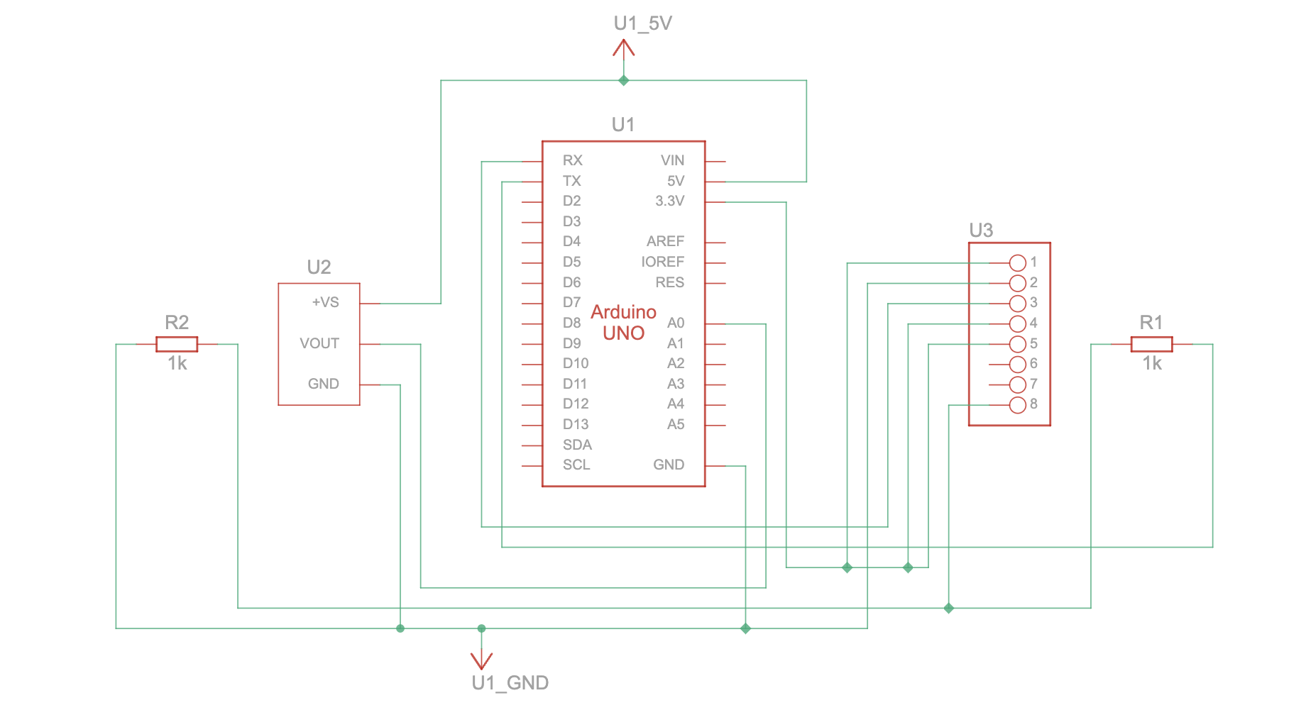

**Code :**

String ssid = "Simulator Wifi"; // SSID to connect to

String password = ""; // No password in virtual WiFi

String host = "api.thingspeak.com";

const int httpPort = 80;

String apiKey = "6VXJKID8U5GRES8B"; // Your ThingSpeak API key

const int tempPin = A0; // LM35 connected to A0

int setupESP8266(void) {

Serial.begin(115200); // Serial communication with PC

Serial.println("AT");

delay(1000); // Wait for ESP8266 response

if (!Serial.find("OK")) return 1;

// Connect to WiFi

Serial.println("AT+CWJAP=\"" + ssid + "\",\"" + password + "\"");

delay(5000);

if (!Serial.find("OK")) return 2;

// Open TCP connection to ThingSpeak

Serial.println("AT+CIPSTART=\"TCP\",\"" + host + "\"," + httpPort);

delay(2000);

if (!Serial.find("OK")) return 3;

return 0;

}

void sendTemperatureData() {

int sensorValue = analogRead(tempPin);

float temperature = (sensorValue * 5.0 / 1023.0) * 100.0; // LM35 formula

Serial.println("Temperature: " + String(temperature) + "°C");

// Construct HTTP request

String httpPacket = "GET /update?api_key=" + apiKey + "&field1=" + String(temperature) +

" HTTP/1.1\r\nHost: " + host + "\r\n\r\n";

int length = httpPacket.length();

// Send message length

Serial.print("AT+CIPSEND=");

Serial.println(length);

delay(1000);

if (!Serial.find(">")) return;

// Send HTTP request

Serial.print(httpPacket);

delay(2000);

if (!Serial.find("SEND OK")) return;

Serial.println("Data sent to ThingSpeak!");

}

void setup() {

setupESP8266();

}

void loop() {

sendTemperatureData();

delay(1000); // Send data

}

**Results :**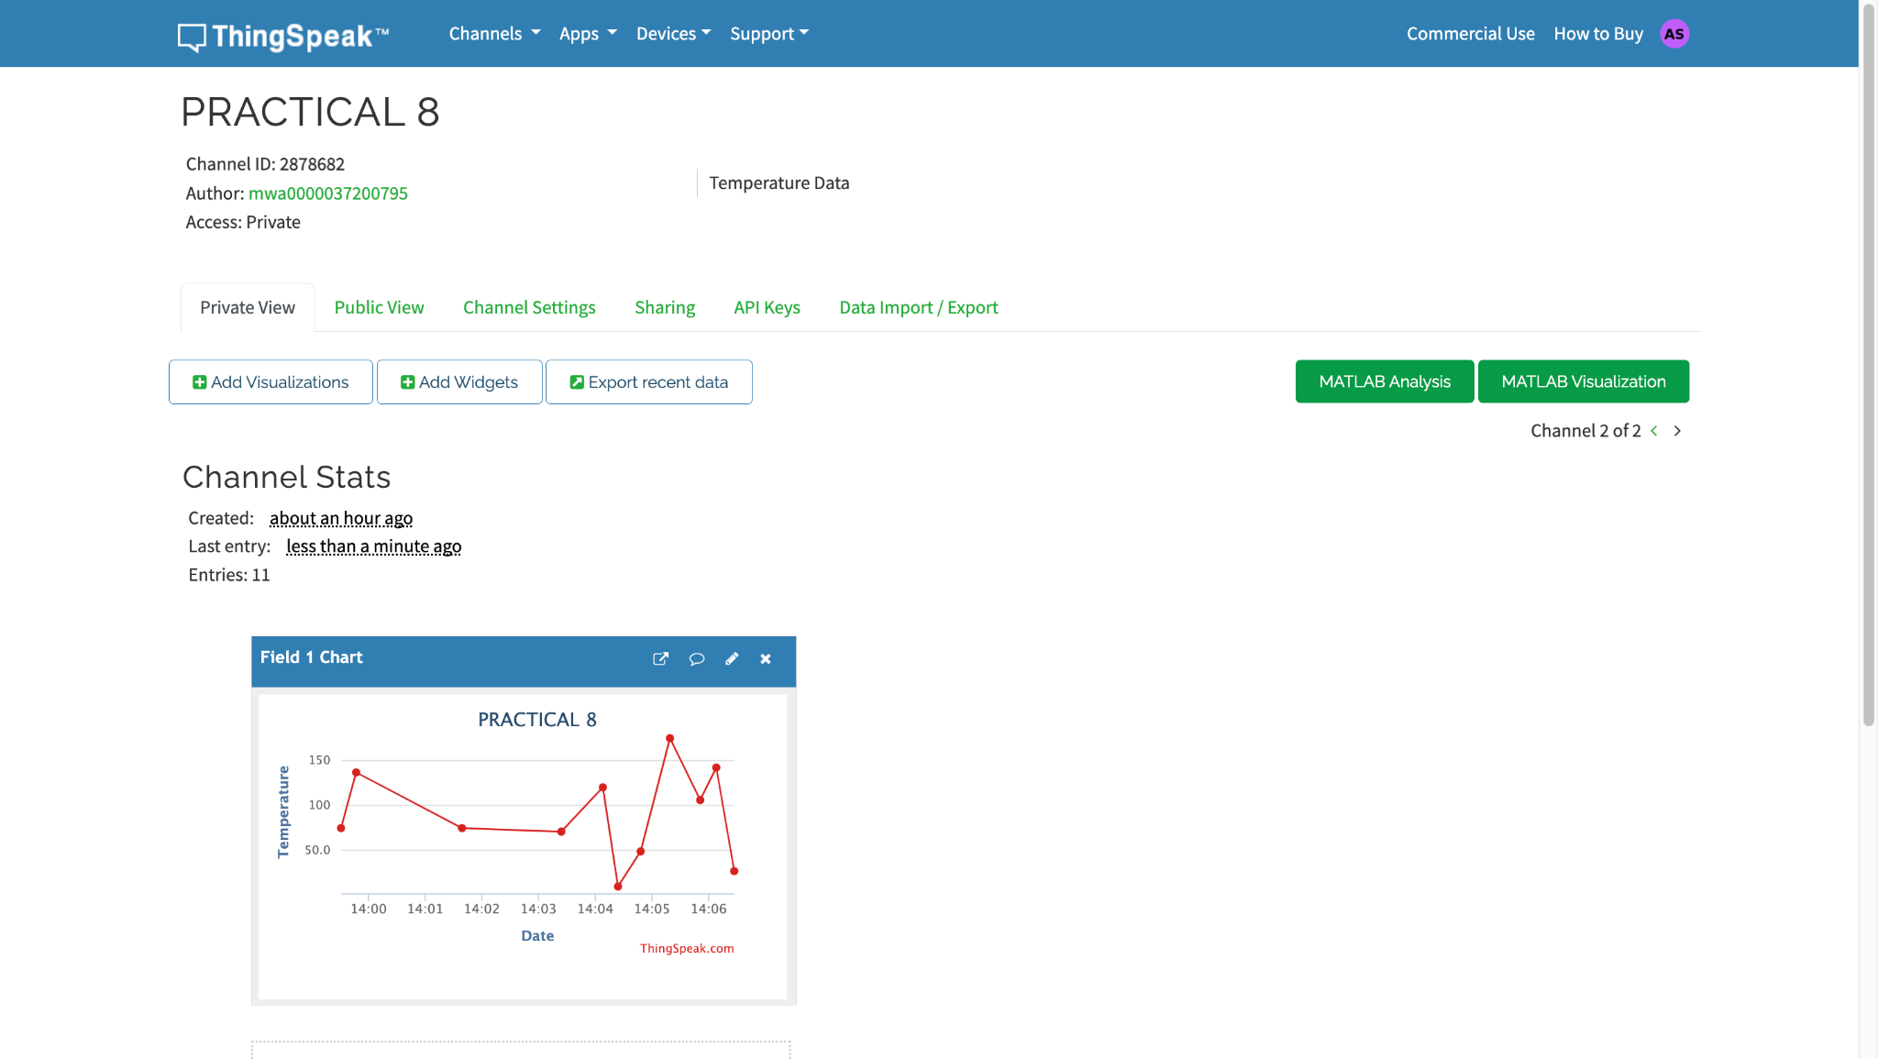

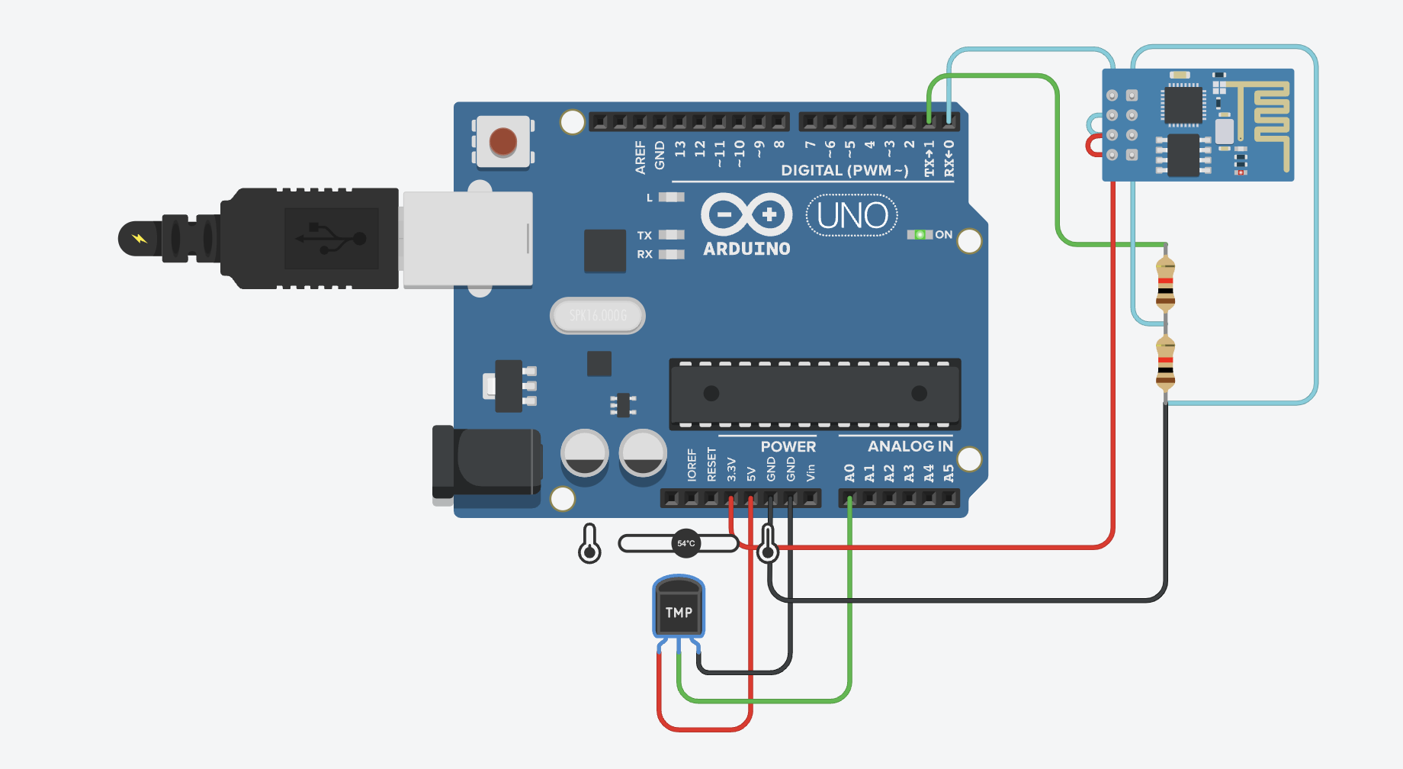

**Conclusion :**

This project successfully collects and uploads temperature data to the ThingSpeak cloud platform using Arduino and NodeMCU. It introduces cloud-based IoT applications and remote data monitoring, forming the basis for more advanced smart environment solutions and predictive analytics.